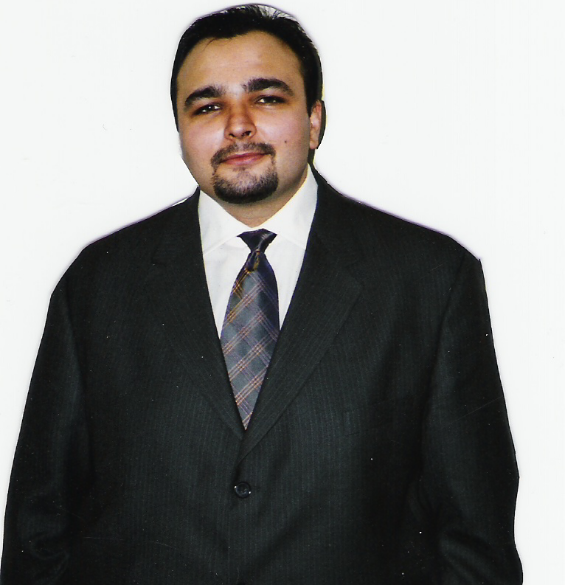

Mike Boldea was born in a small northern Romanian Village. At the age of nine, his entire family was deported from Romania for smuggling Bibles. His grandfather, Dumitru Duduman started an outreach ministry called “Hand of Help” of which Mike is now Chairman.

Mike has traveled internationally with Dumitru for over 11 years acting as Dumitru’s translator. They shared their testimonies, as well as an important message God gave Dumitru for the United States.

Recently Mike has translated the book entitled “ Life In Christ “ which Dumitru had penned prior to his death. The testimonies of those that were persecuted for their faith must live on to build up the body of Christ. Mike continues to operate in his gift as an Evangelist to exhort the body of Christ to present itself with a garment clean before our Lord.

Michael has a strong Christian heritage coming from a line of 4 generations of Christians. In the village of Hinceste Romania his Great grandfather was one of the first Christians converted there and his grandfather was a pastor and his father pastors the “Messiah” church in Botosani Romania with over 800 members. Their family worked with Richard Wurmbrandt, Harlan Popoff, and brother Andrew taking bibles to the underground Church.

Michael has seen the presence of God in accomplishing the work that his family was called to. In the face of great persecution and opposition thousands of bibles were given to the Christians of Romania even though it was punishable by imprisonment if caught. His grandfather Dumitru Duduman did suffer greatly being imprisoned for his faith. Under extreme torture he never recanted his faith and stands as a witness of faithfulness to this day in Romania.

Biography of Mike Boldea
Mike Boldea

