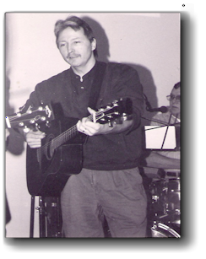
Biography of Gene Schmidt (Special Music).

Gene Schmidt, singer, songwriter, and musician has been writing as well as performing Christian music for over two decades. His accomplishments include composing hundreds of songs to support various causes from homelessness, missions, right to life, and songs for the persecuted church. His acoustic ability has a comforting measure to soften even the hardest of hearts.

He has traveled sharing in music and ministry in Germany, Switzerland, Australia, Canada, and a country most dear to his heart Romania. Gene has joined with Michael Boldea for many tours around the country and has shared first hand experiences of God moving in the supernatural, all to the glory of our King.

A reference from “Voice Of The Martyr’s” Ray Thorne…...
Gene Schmidt
(GENO)
I have known Gene for 7 years, as our relationship developed over the years, it is obvious that Gene has a real passion and deep commitment to Jesus Christ. He has faithfully ministered to the body of Christ, not only in America, but in other parts of the world, especially Romania.

Gene has served the suffering body of Christ by supplying humanitarian aide and relief supplies to those who the Lord Jesus talks about in Mathew 25. Because of his tireless efforts with the persecuted and suffering saints, he has first hand experience to draw from.

Genes has an incredible gift of music to offer the body of Christ, and every song he sings, reflects biblical truth and the realities of what it truly means to take up your
cross and follow Jesus. Gene has an uncanny way of using his music to
disciple the body of Christ, I highly recommend him as a man of God, and as
a prophetic voice for this generation.
Ray Thorne ( The Voice of the Martyrs)

Hand of Help
1012 S. 3rd Street
Watertown, WI. 53094
920-206-9910

E-mail: HandofHelpOffice@aol.com

Web: handofhelp.com

Biography of Gene Schmidt
Gene Schmidt

